

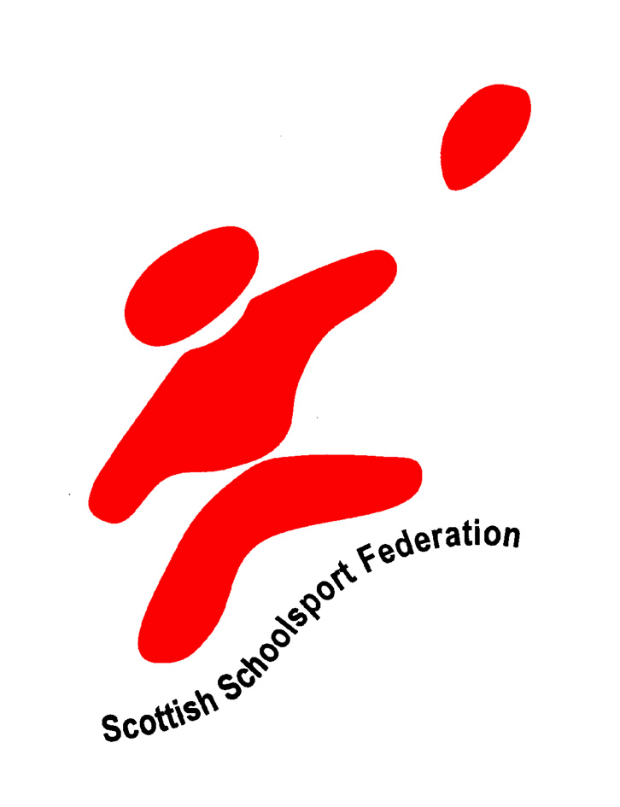

SSF/SLANOPE CONFERENCE
A Sporting Nation - What does this mean for PE and School Sport?

22 May 2008

Ratho Edinburgh International Climbing Arena

This conference will interest PE staff, sport development staff, active schools, teachers involved in school sport, National governing bodies of sport, sportscotland, Scottish Government Sports Division and anyone with an interest in PE and school sport

CONFERENCE PROGRAMME
08.30 am` | Briefing for workshop facilitators
9.30 - 10.00 am | Registration and tea/coffee
10.00 am | Introduction and Welcome  Maureen Watt (Minister for Schools and Skills)
10.15 - 11.00 am | Keynote  Sir Bill Gammell  Independent view of the benefits of School Sport
11.00 - 11.40 am | Workshop Session (refreshments at table)
11.50 - 12.30 pm | A Director's view on PE and schools sport.  Gordon Ford (Director of Education & Cultural Services, West Lothian Council)
12.30 - 1.40 pm | LUNCH
1.40 - 2.10 pm | Brian Cookin, President Head teachers Assosciation of Scotland (HAS) - A Head Teacher's perspective on PE and school sport.
2.15 - 2.55 pm | Workshop 2
3.00 - 3.30 pm | Question Forum in workshop groups  "Red, Amber and Green" on the successes of school sport and the barriers.
3.40 - 4.00 pm | Short plenary and conference sum up

Workshops

(Conference Delegates to participate in 2 workshops from this list)

Please tick
- Reaching Higher - Jacqueline Lynne

- Transitions - Kay Gibson

- More Choices in PE - Suzanne Hargreaves

- Links to Clubs and Communities - Stuart Younie

- School Sport - the case for Chris Robinson

- 120 Hours PE - Gail Hally

- Sports Schools - Shirley - Anne Smith

- LTS Health and Wellbeing Outcomes - Morna Crombie

- Pathways to participation and performance - Alan Clark

- Schools community links - Johnny Croall

- Fit for girls - Hazel Williamson

- Secondary based primary focused PE - Steve Holmes

- Active schools - John Gillespie

- A Head Teachers perspective on PE and school sport TBC

- PE and school sport in the private sector TBC

Booking Form

Please book me on to the SSF/SLANOPE Joint Conference on 22 May
Name:
Organisation:
Address:-
Postcode:-
Telephone Number:-
Fax Number:-
Email Address:-

Delegate Rates
SSF affiliated members £49.00
Non SSF Members £79.00

Method of Payment:-

I enclose a cheque* Please invoice

*Please make cheques payable to West Lothian Council.

Signed:-

Please list below any special dietary/  accommodation requirements |  | Any additional comments/requirements

Please return to:
Workshop choice in order of preference:

1. …………………………………….

2. …………………………………….
Lynne Taylor
West Lothian Council
Lindsay House
South Bridge Street
Bathgate
West Lothian
EH48 1TS
Tel: 01506 776092
Fax: 01506 776095

Email: lynne.taylor@westlothian.gov.uk

